Site 15 – Rookery Farm – Machinery Yard & Paddock
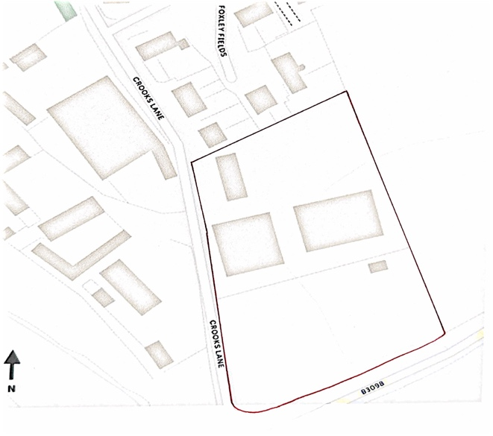
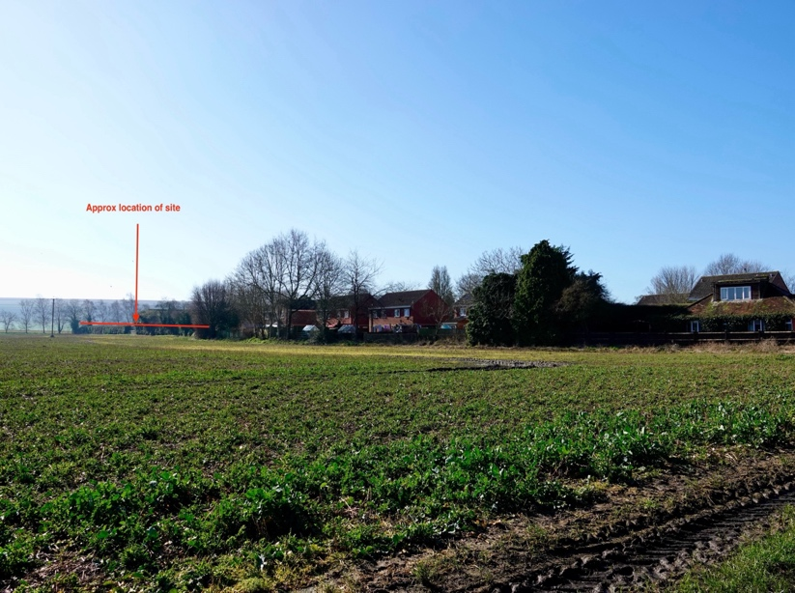
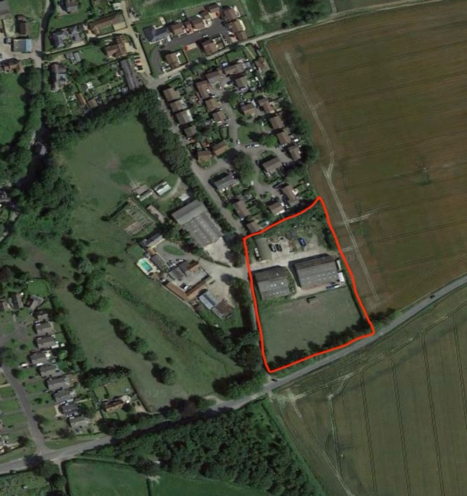
Proposal:

- 20 (approx.) new 2/3/4/5-bed houses on existing yard and workshops, barns and paddock site

- Site area – 1 ha/ 2.47 acres (approx.)

Key Factors:

- Partly brownfield site located between development boundary and existing farm buildings

- Accessed via minor single-track lane

- Village shop/pub approximately 1 kilometre walking distance

- Large site with good potential for affordable housing

- Opportunity for highways improvements to Crooks Lane

- Logical squaring off of village boundary

- Likely availability towards end of Plan period

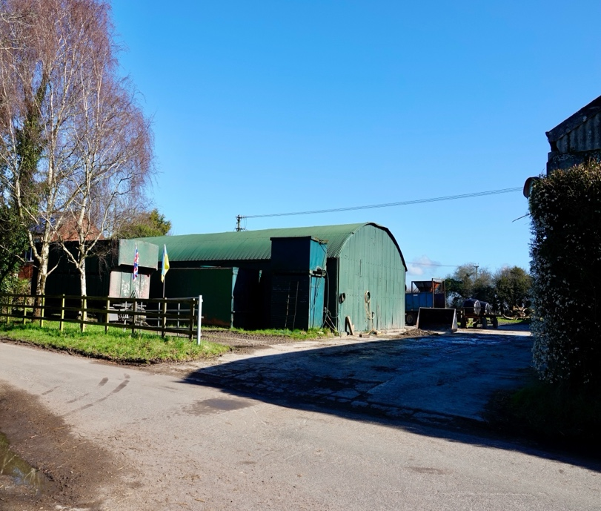

Site 16 – Rookery Farm, opposite Foxley Fields

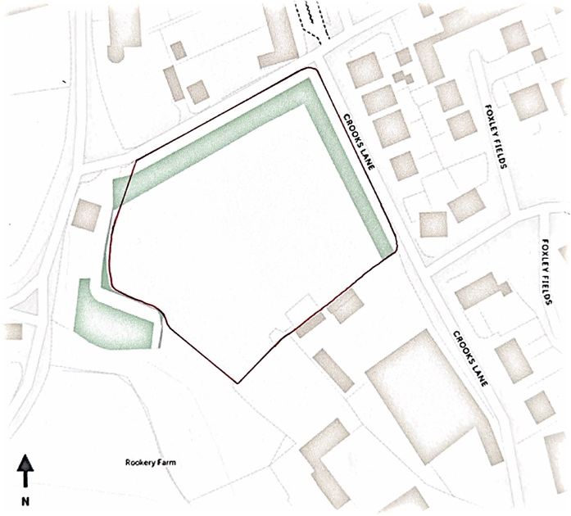

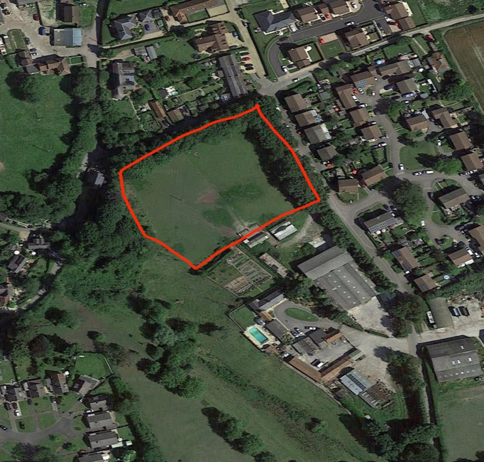

Proposal:

- 10-15 (approx.) new 2/3/4-bed houses on existing field including affordable homes

- Site area – 0.71 ha/ 1.75 acres

Key Factors:

- Greenfield site, outside but adjoining development boundary on 2.5 sides and mostly adjoined by further buildings

- Minor impact on long views towards Salisbury Plain from Crooks Lane

- Village shop/pub approximately 860 metres walking distance

- Accessed via minor single-track lane

- Potential to contribute to improvement of pedestrian access to B3098

- Substantial existing natural screening from road and neighbouring properties

- Large sized site with good potential for affordable housing
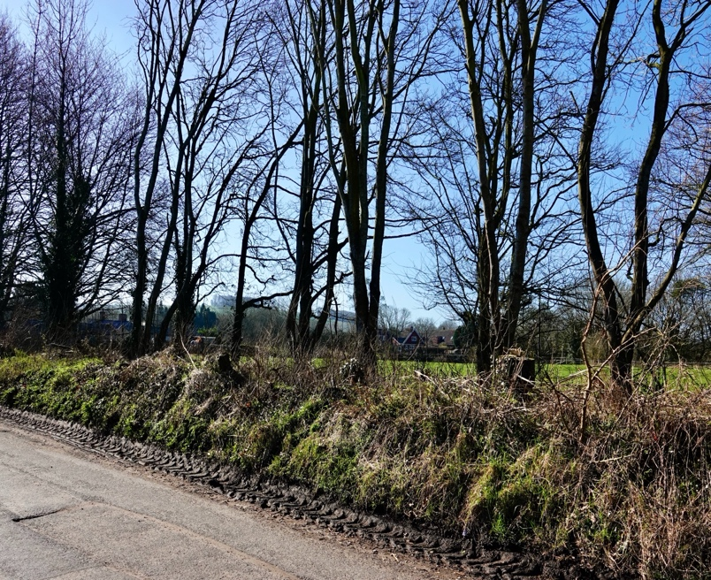

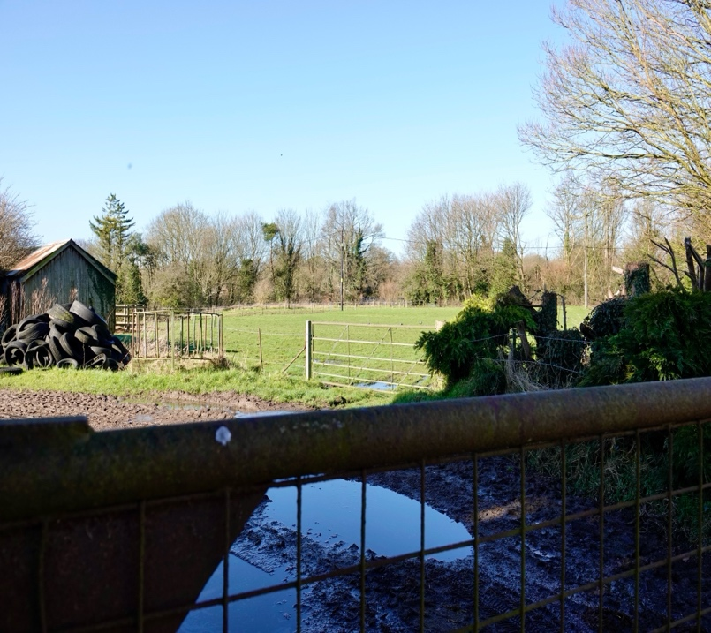
Site 17 – Rookery Farm –
opposite “Lancasters”

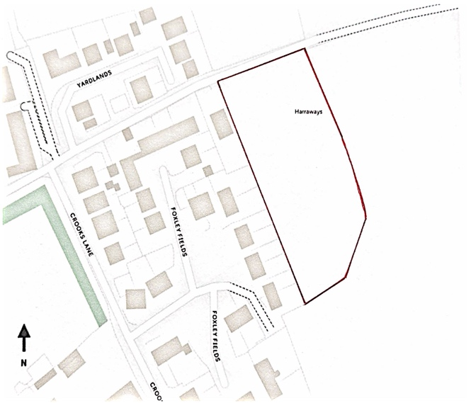

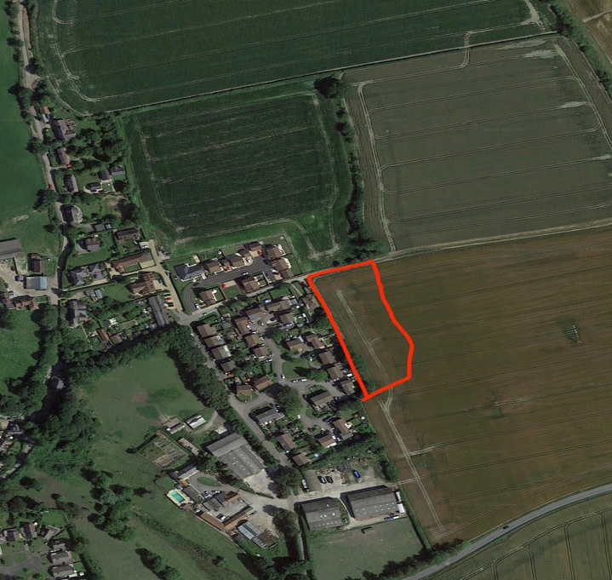
Proposal:

- 8 (approx.) x 3, 4 & 5 bed houses on existing field, including affordable housing

- Site area – 0.55 ha/ 1.36 acres

Key Factors:

- Greenfield site located outside but adjacent to village development boundary, with existing development on only one side.

- Projecting into existing open farmland on 3 sides, impacting on views towards Salisbury Plain from footpath and highly visible across open fields

- Village shop/pub approximately 960 metres walking distance

- Accessed directly from minor single-track lane with no footpaths

- Public footpath on northern boundary

- Medium sized site with potential for affordable housing

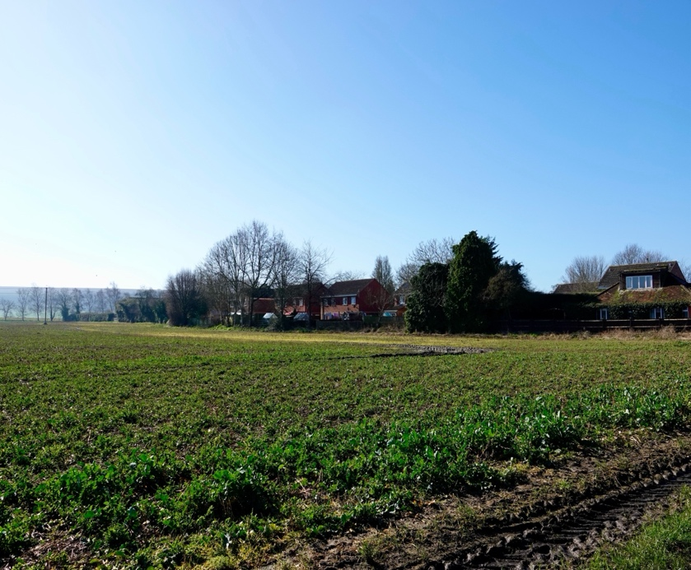

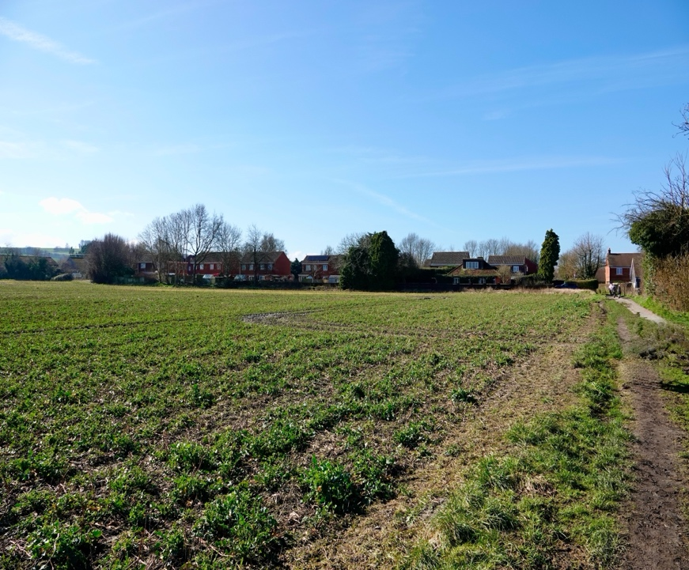
Site 18 – Rookery Farm –
“Gunpark and Island”

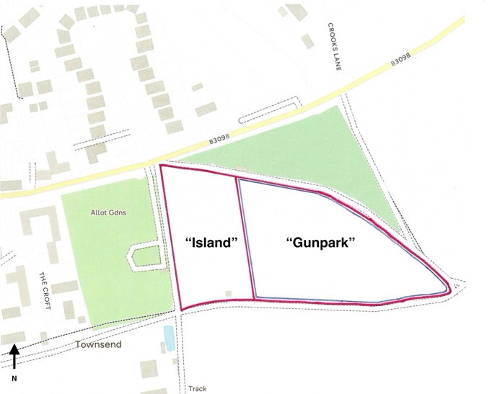

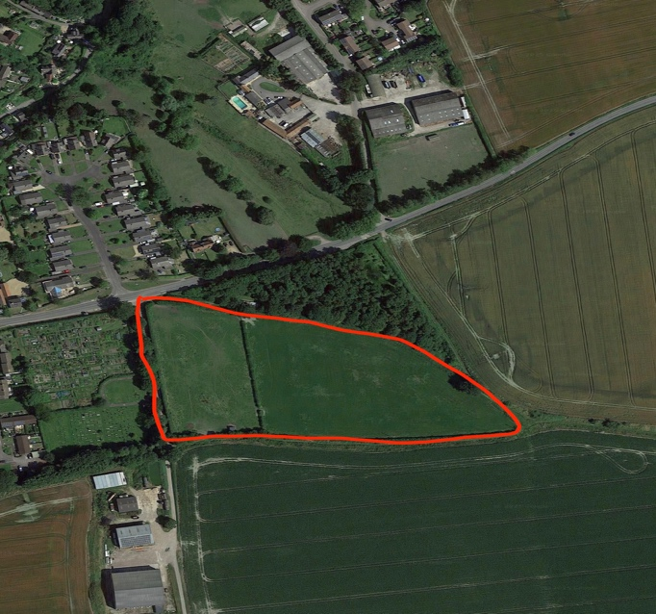

Proposal:

- 20-30 (approx.) x 3, 4 & 5 bed houses including affordable homes on existing field

- Site area – 2.38 ha/ 5.88 acres

Key Factors:
- Greenfield site, located outside and separated from village development boundary, with no existing development adjacent

- Projecting into existing open farmland, impacting views towards and from Salisbury Plain from publicly accessible areas and visible across open fields

- Village shop/pub approximately 920 metres walking distance

- Accessed directly from B3098

- Adjacent to existing local Green Spaces of Farmer’s Field and The Holloway

- Public footpaths on north and southern boundaries

- Large sized site with good potential for affordable housing and varied housing mix
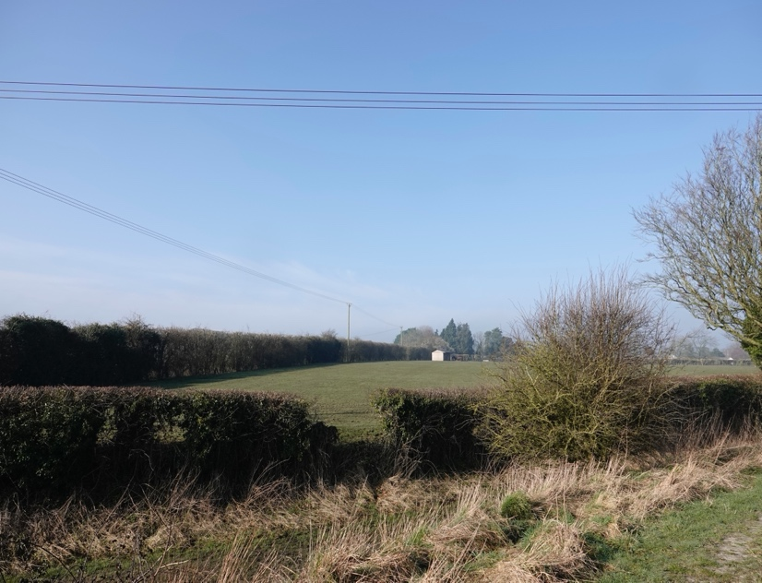

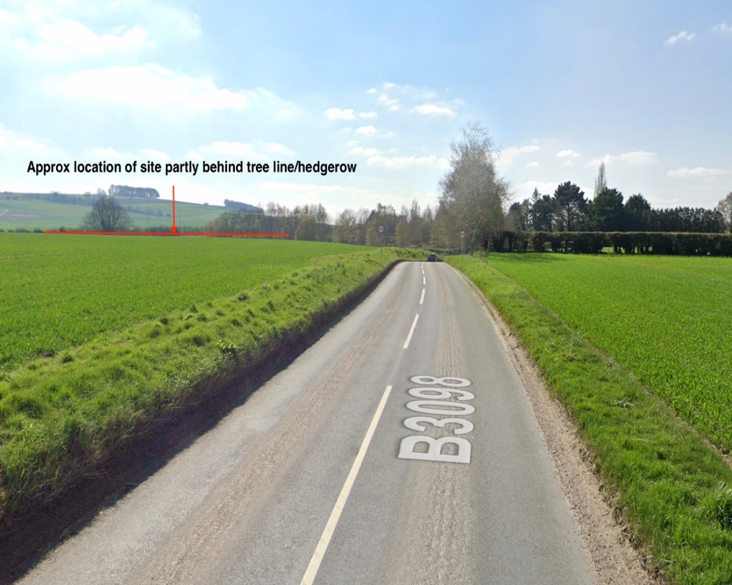
Site 19 – Rookery Farm –
“Gunpark” site only

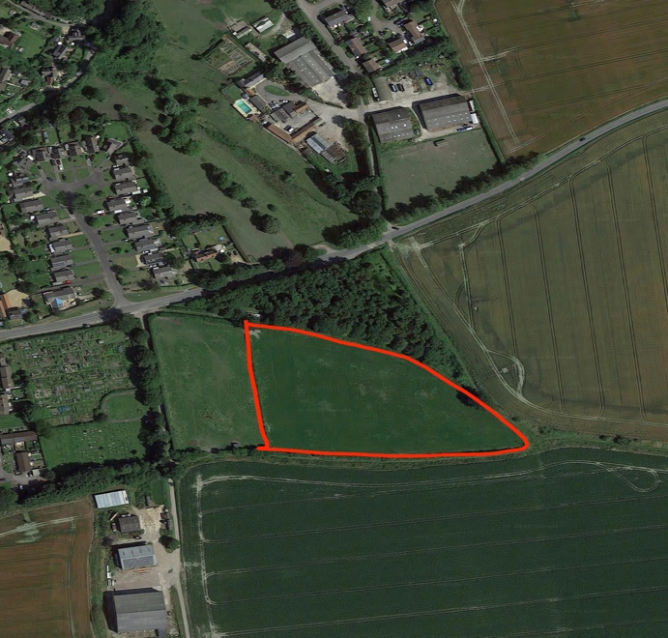
Proposal:

- 22 (approx.) houses including affordable homes on existing field

- Site area – 1.53 ha/ 3.78 acres

Key Factors:
- Greenfield site, located outside and separated from village development boundary, with no existing development adjacent

- Projecting into existing open farmland, impacting views towards and from Salisbury Plain from publicly accessible areas and visible across open fields

- Accessed directly from B3098

- Village shop/pub approximately 920 metres walking distance

- Adjacent to existing green spaces of Farmer’s Field and The Holloway

- Public footpaths on north and southern boundaries

- Large sized site with good potential for affordable housing and varied housing mix
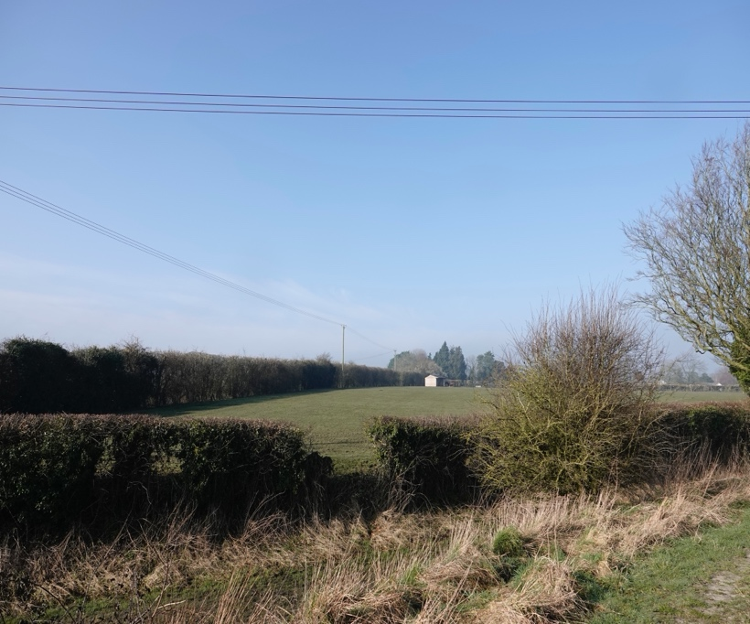

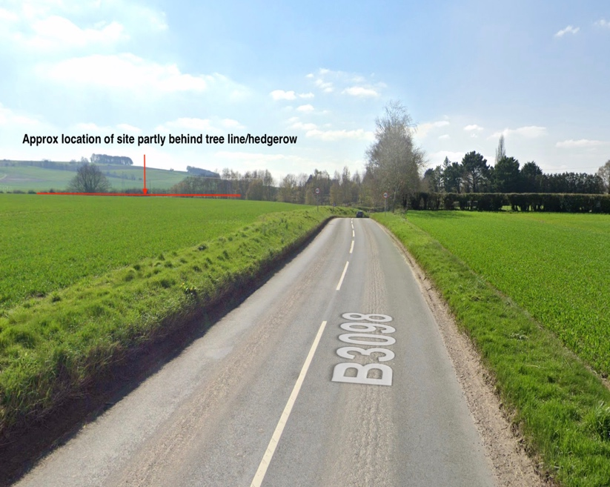

SITE 20 - Knowle House,
Crookwood Lane

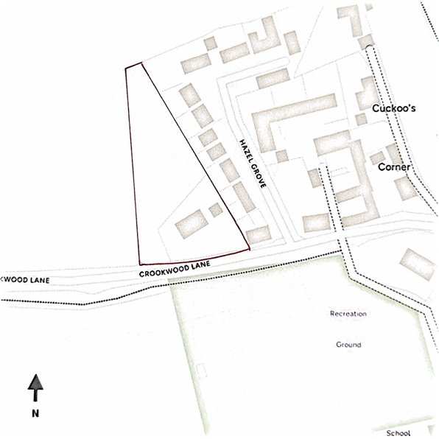

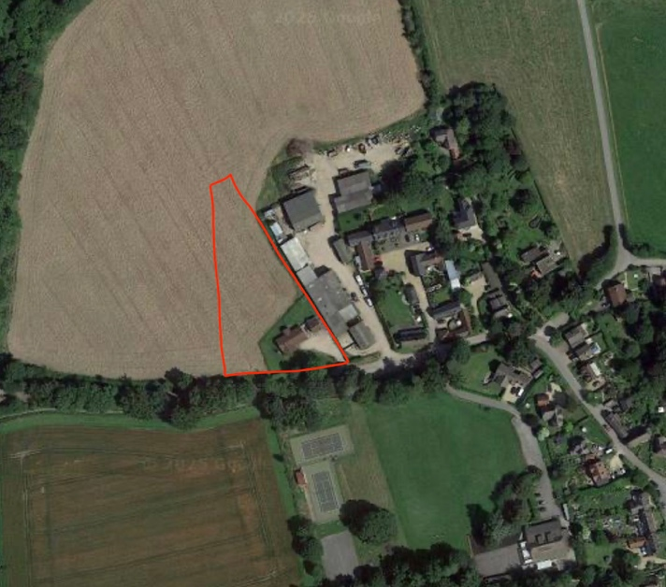
Proposal:

- 4 houses (3/4-bed) in place of existing bungalow, garden and part of adjoining field

- Site area – 0.14 ha/ 0.35 acres

Key Factors:

- Brownfield site adjacent to development boundary, projecting into open fields with no obvious boundaries

- Village shop/pub approximately 443 metres walking distance

- Access onto narrow mostly single-track village through road

- Close to “Breach Hanging” ancient woodland County Wildlife Site

- Small site with no affordable housing proposed

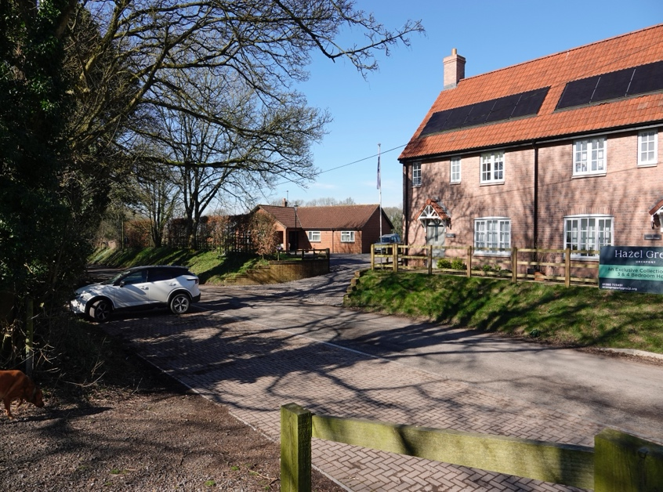

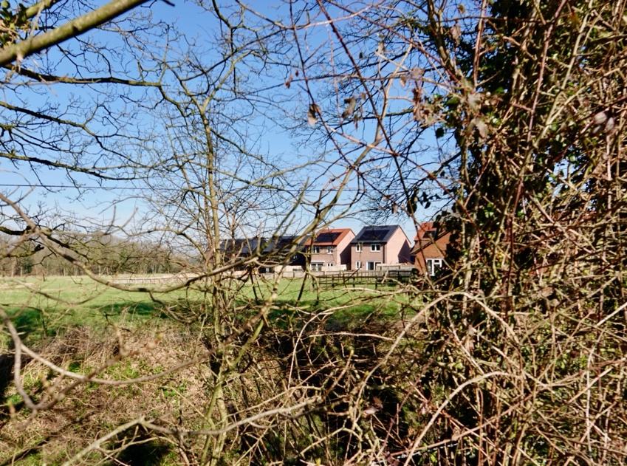

Site 21 – Jasmine Cottage and Firlings,
Uphill
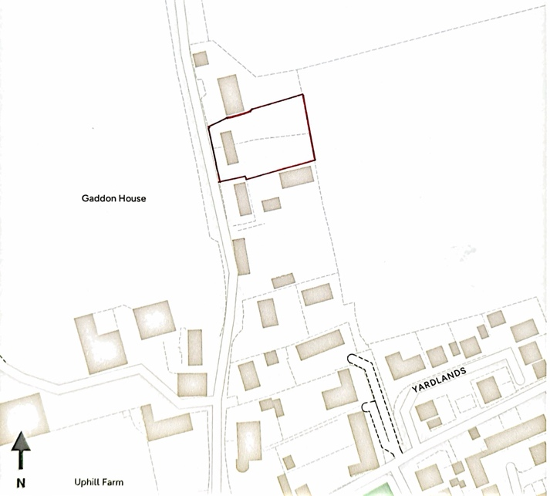
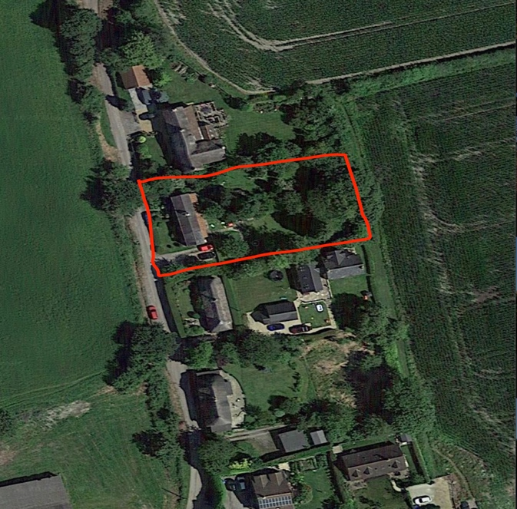

Proposal:

- 2 houses in rear garden of existing 2 “Trust Houses”

- Site area 0.2 ha/ 0.5 acres

Key Factors:

- Brownfield site, within existing development boundary with 2 existing houses on site

- Village shop/pub approximately 914 metres walking distance

- Accessed directly from minor single-track lane with no footpaths

- Small scale with no proposal as yet for affordable housing

- Uncertainty about timescale for development

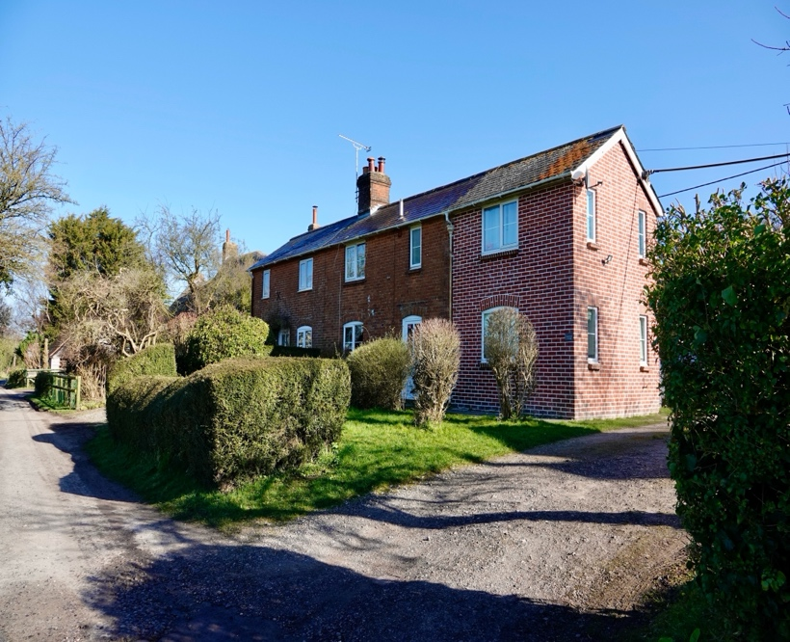

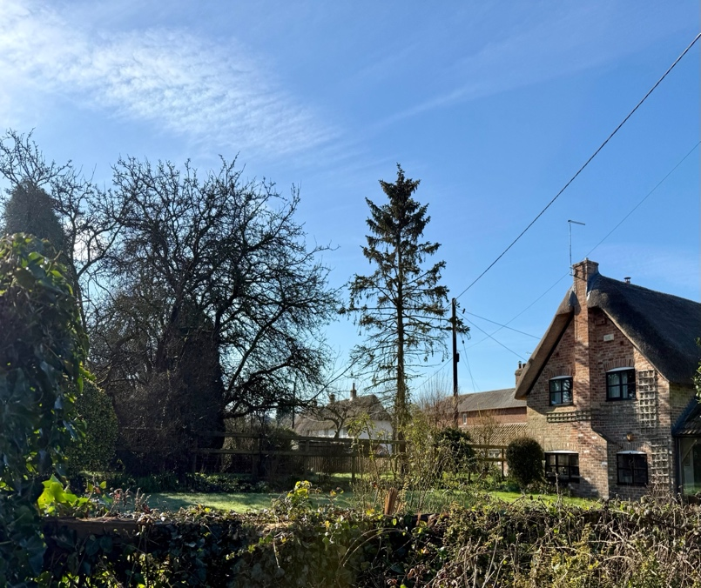
SITE 22: - Manor Farm land
Adjacent to Ostler’s Yard, A342

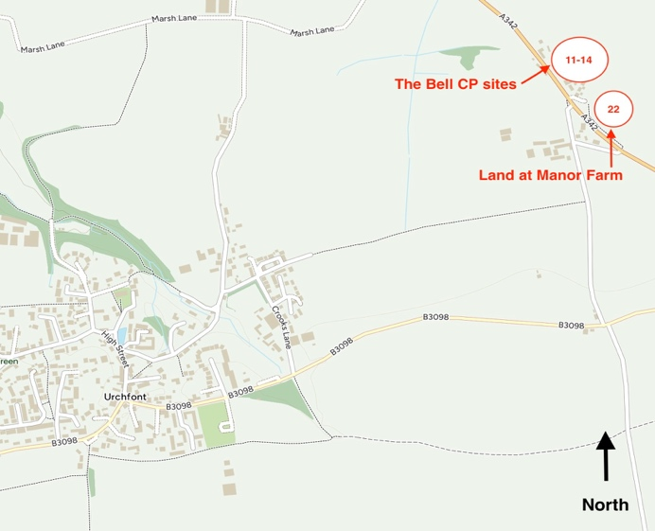

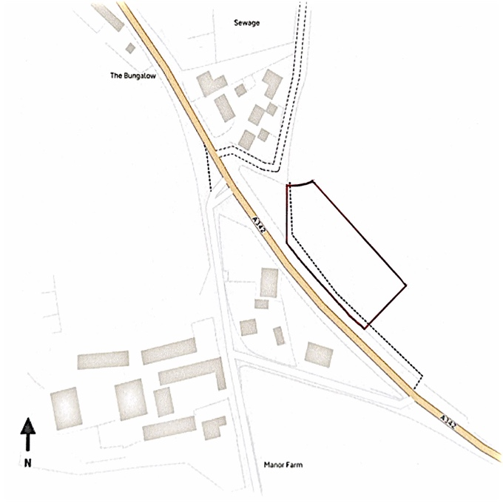
Proposal:

- 10 (approx.) houses (2, 3, 4 & 5-bed) on part of existing field

- Site area 0.75-1 ha/ 1.85-2.47 acres

Key Factors:

- Greenfield site, located away from Urchfont village

- Within North Wessex Downs Area of Natural Beauty

- Village shop/pub approximately 2 kilometres walking distance

- Access direct from A342

- Large size scheme with some affordable housing potential

