Site 8 Uphill Farm - Workshop

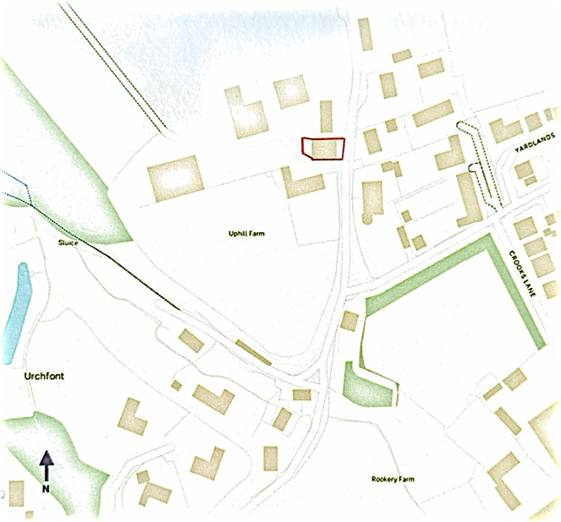

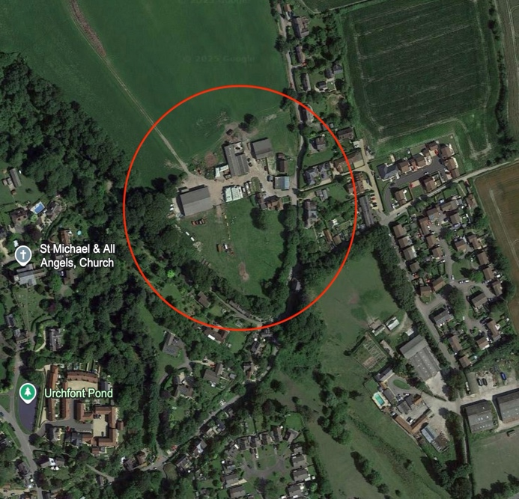
Proposal:

- One house to replace existing workshop structure

- Site area – 0.03 ha/ 0.74 acre

Key Factors:

- Brownfield site, adjacent to development boundary (to east opp. side of road)

- Village shop/pub approximately 760 metres walking distance

- Access off narrow, single-track lane with no pavements (Friars Lane/The Bottom/Uphill)

- Possible contamination

- Small site with no affordable housing potential

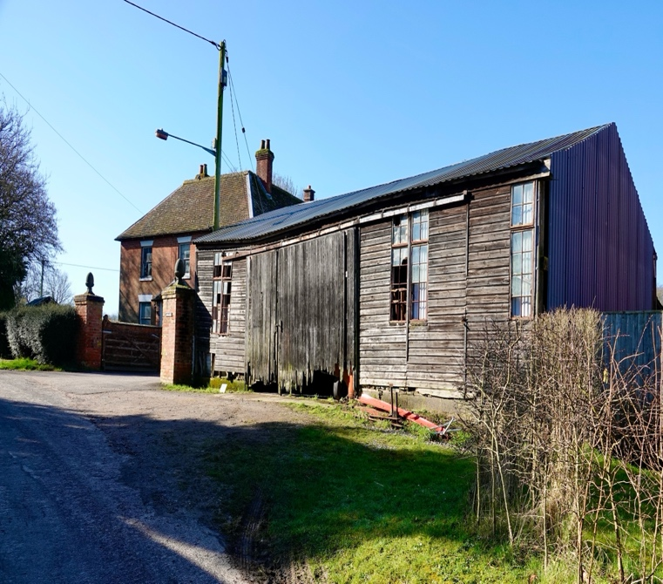

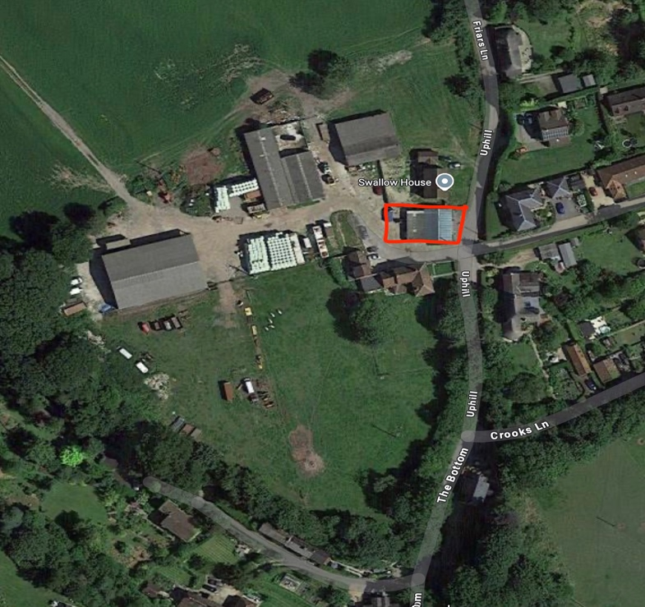
Site 9 Uphill Farm – North Paddock
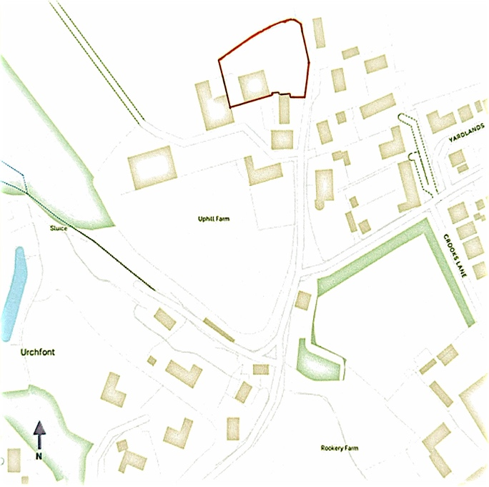

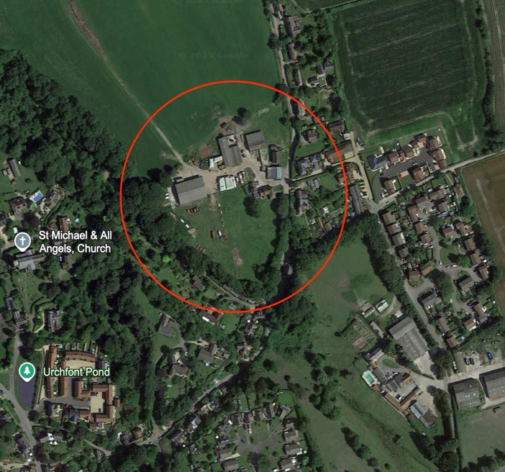
Proposal:

- 3-4 (approx.) houses to replace existing farm buildings, yard and paddock

- Site area – 0.2 ha/ 0.49 acre

Key Factors:

- Brownfield / Greenfield mix; adjacent to development boundary (to east opp. side of road)

- Open views of N. Wessex Downs from lane across northern edge of site

- Village shop/pub approximately 820 metres walking distance

- Access off narrow, single-track lane with no pavements (Friars Lane/The Bottom/Uphill)

- Public footpath on northern boundary

- Close to Listed Building (Carina Cottage)

- Small site with no affordable housing potential

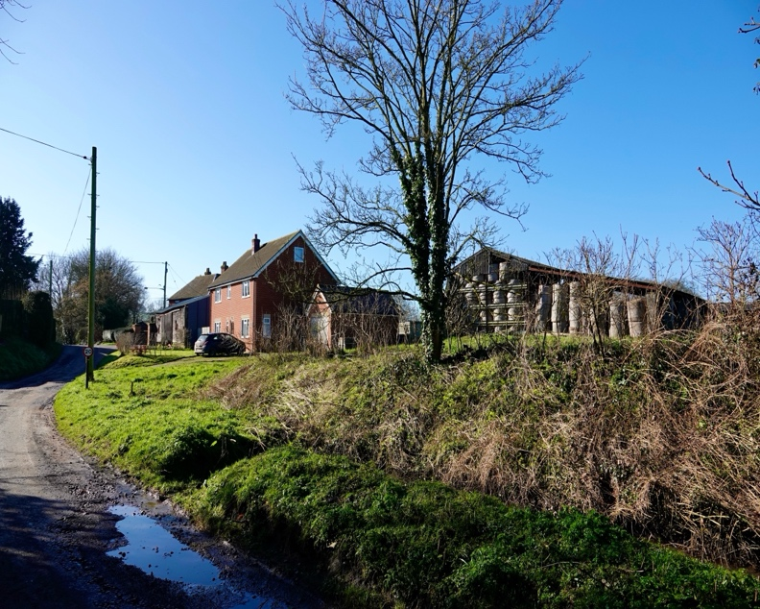

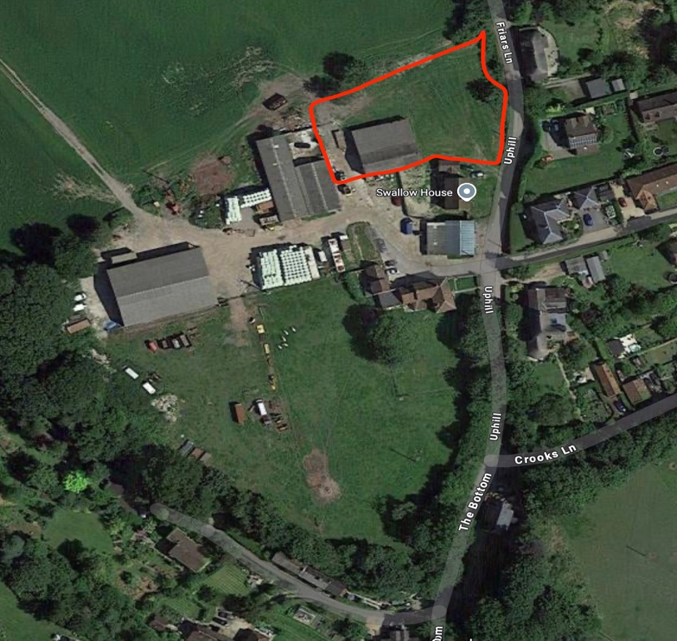
Site 10 Uphill Farm - Combined sites

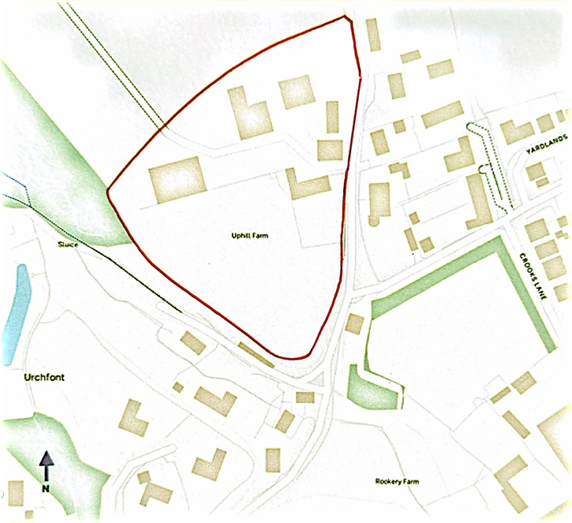

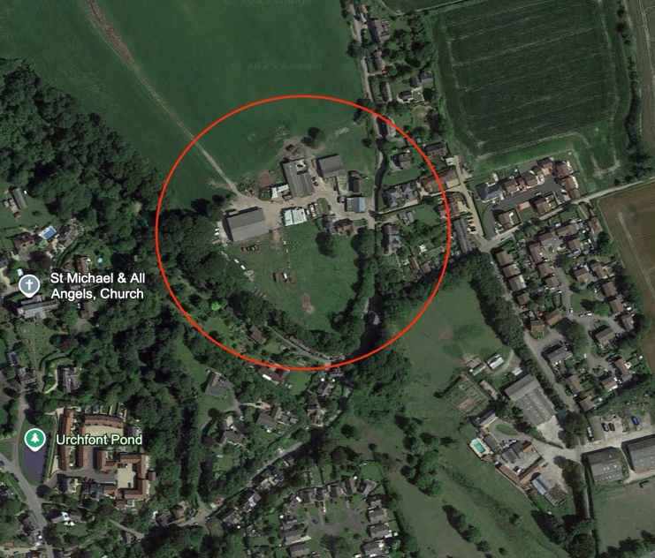
Proposal:

- 15-20 (approx.) 2-,3-,4- and 5-bed houses on farm paddocks
- Site area – 1.79 ha/ 4.4 acres

Key Factors:
- Mixed greenfield/ brownfield site, outside but adjacent to development boundaries (to south and to east opp. side of road)
- Village shop/pub approximately 803 metres walking distance
- Access off narrow, single-track lane with no pavements (Friars Lane/The Bottom/Uphill)
- Public footpath on northern boundary
- Open views of North Wessex Downs from lane across northern edge of site
- Northern part close to Listed Building (Carina Cottage)
- Local Green Space to south-west below site
- Steep embankment down to south-west of site, very close to existing properties
- Large sized site with good potential for affordable housing in accordance with WC policy

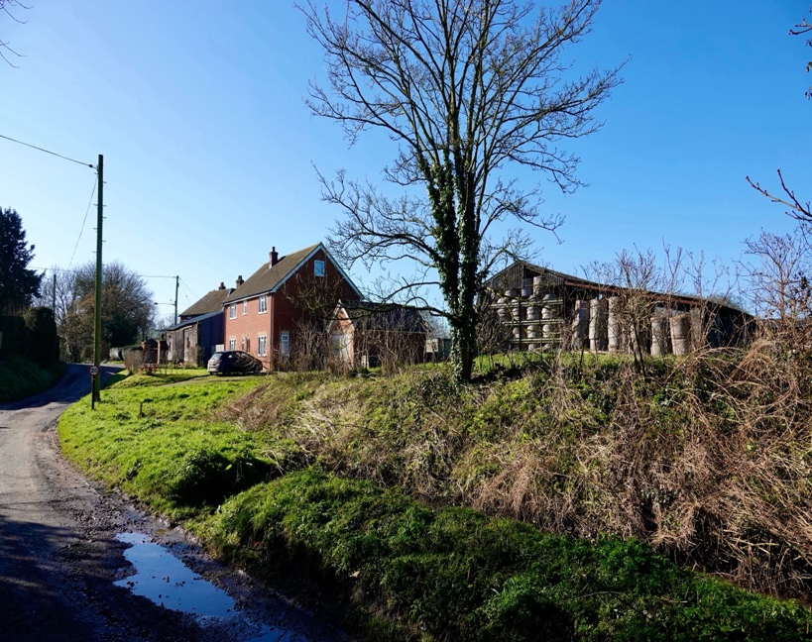

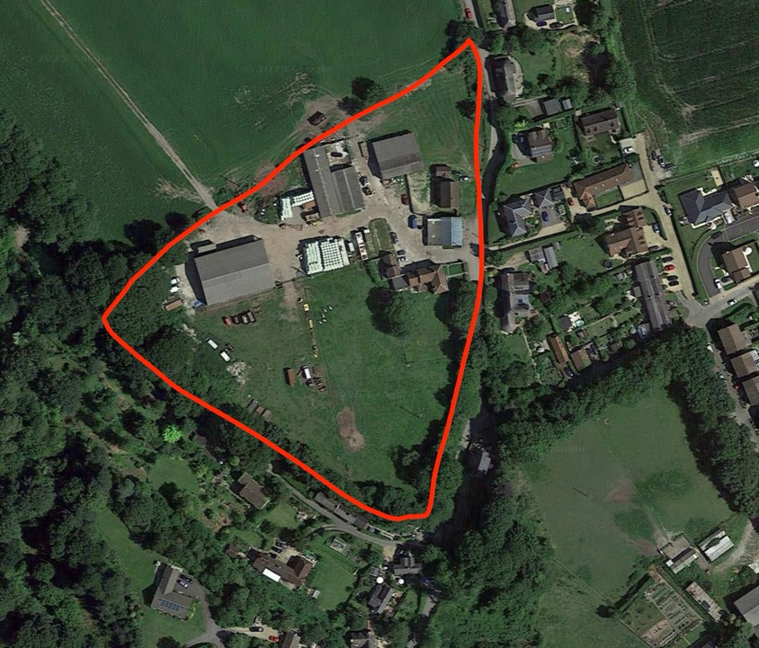
Site 11 The Bell House Caravan Park - “Hazel”

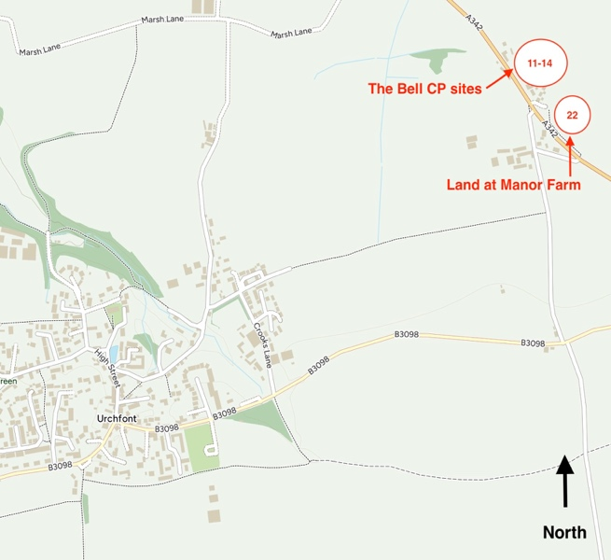

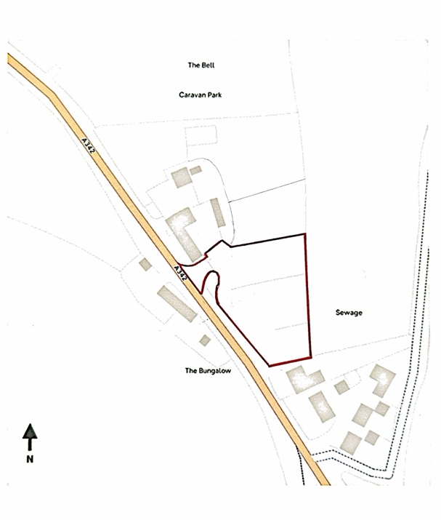
Proposal:

- 6 (approx.) 2-,3- & 4-bed houses on existing camping field

- Site area – 0.34 ha/ 0.84 acres

Key Factors:

- Greenfield site, located away from Urchfont village

- Within North Wessex Downs Area of Natural Beauty

- Urchfont village shop/pub approximately 2.2 kilometres walking distance

- Access direct from A342

- Medium sized site with limited potential for affordable housing

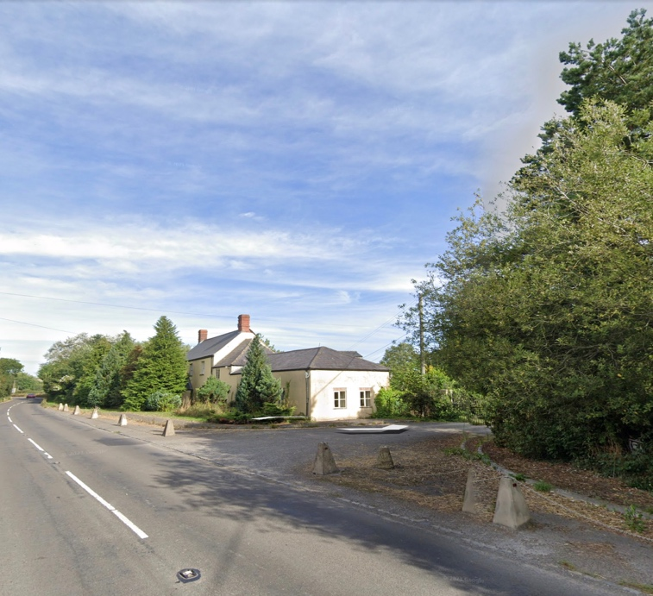

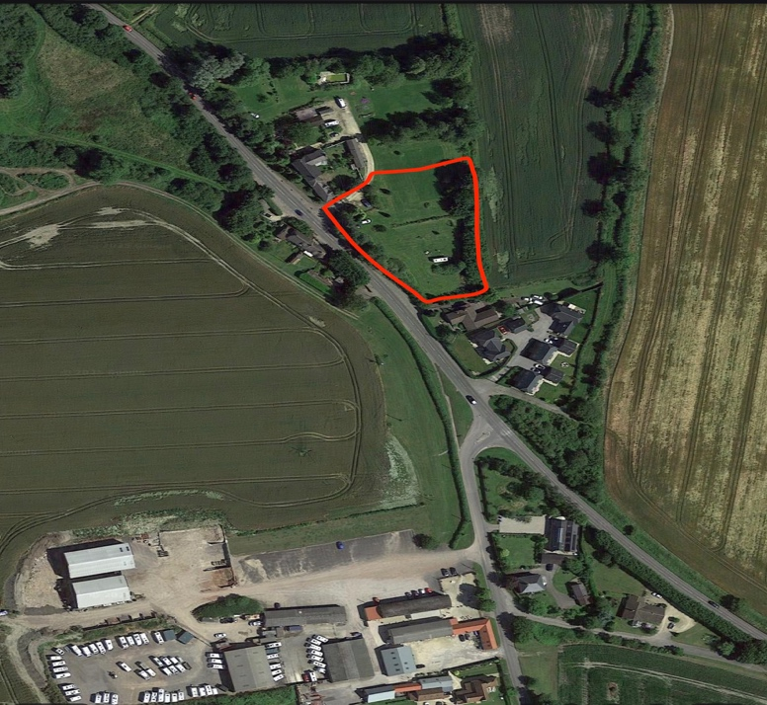
Site 12 The Bell House Caravan Park - “Cherry”

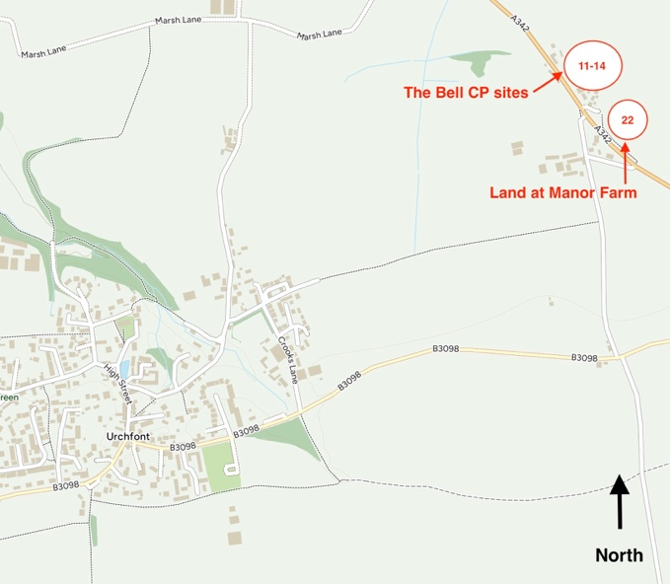

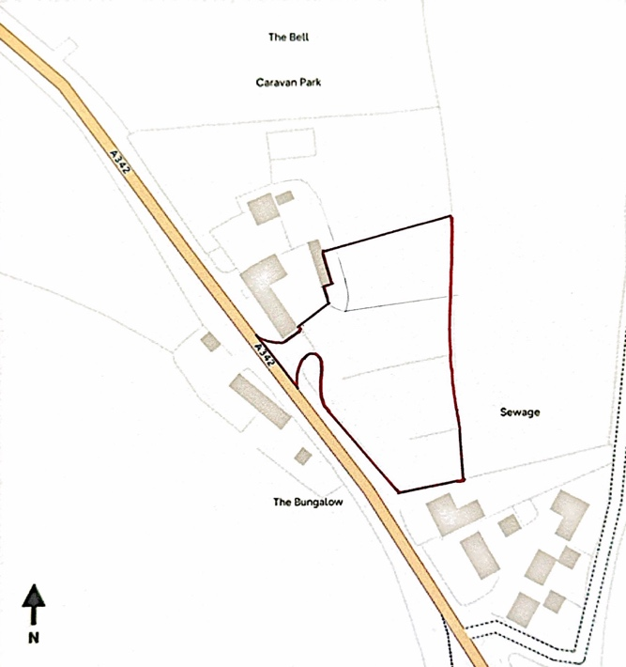
Proposal:

- 8 (approx.) new 2-, 3- &4-bed houses on existing camping field
- Site area – 0.46 ha/ 1.14 acres

Key Factors:

- Greenfield site, located away from Urchfont village

- Within North Wessex Downs Area of Natural Beauty

- Urchfont village shop/pub approximately 2.2 kilometres walking distance

- Access direct from A342

- Medium sized site with limited potential for affordable housing

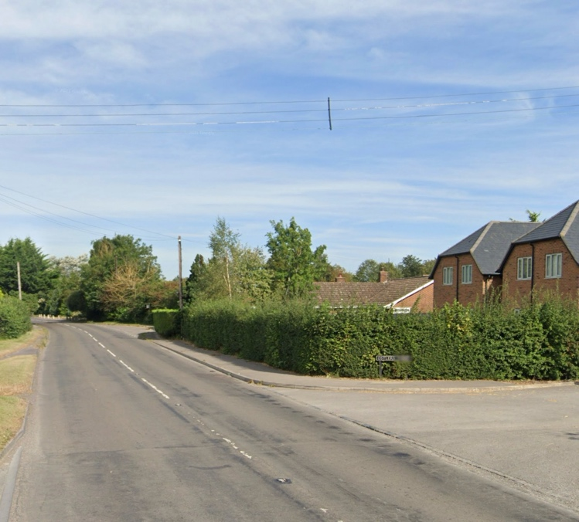

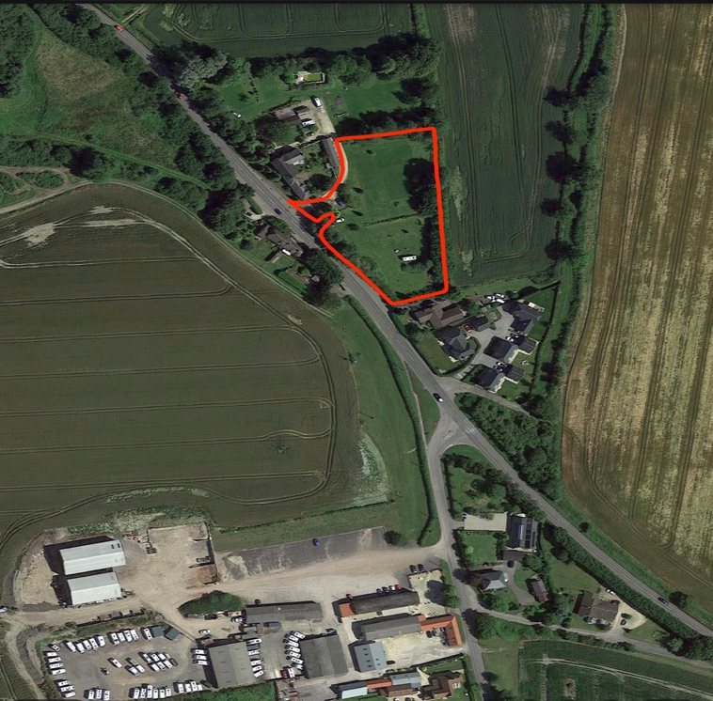
Site 13 The Bell House Caravan Park - “Walnut”

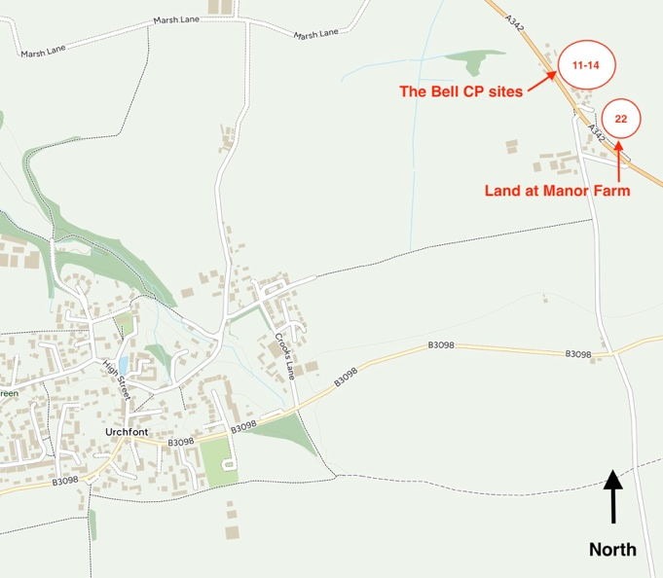

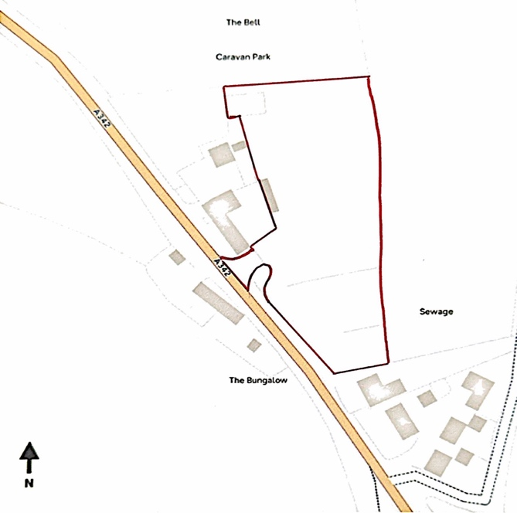
Proposal:

- 13 (approx.) new 2-, 3- &4-bed houses on existing camping field

- Site area – 0.74 ha/ 1.83 acres

Key Factors:

- Greenfield site, located away from Urchfont village

- Within North Wessex Downs Area of Natural Beauty

- Urchfont village shop/pub approximately 2.2 kilometres walking distance

- Access direct from A342

- Large sized site with good potential for affordable housing

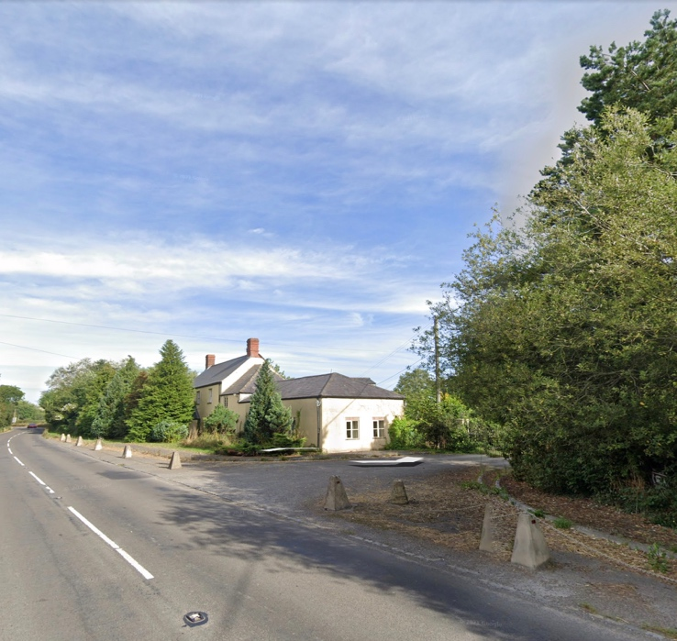

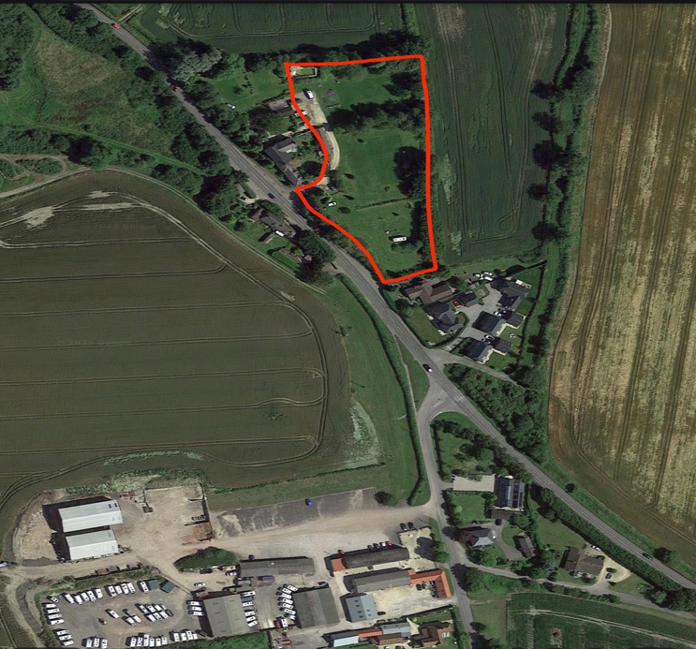
Site 14 The Bell House Caravan Park –
“Entire site”

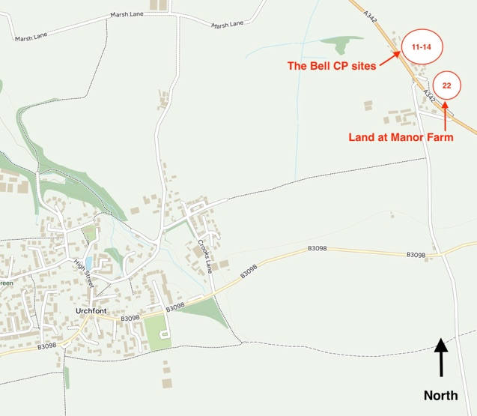

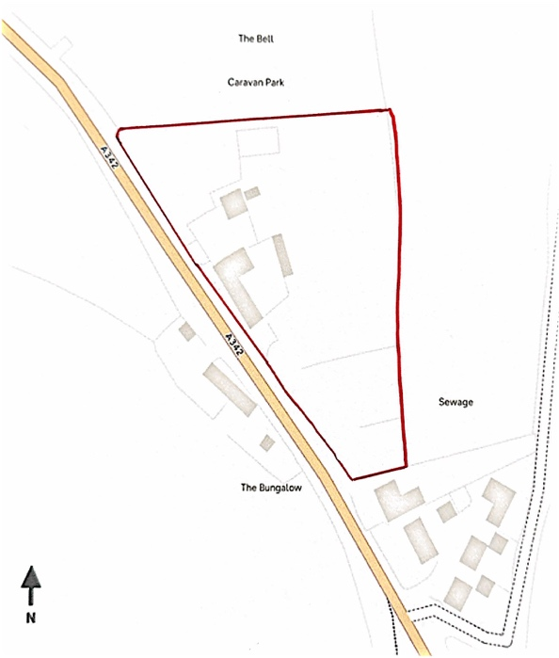
Proposal:

- 15 (approx.) new 2-, 3- & 4- bed houses on entire site

- Site area – 1.14 ha/ 2.82 acres

Key Factors:

- Mixed greenfield/brownfield site, located away from Urchfont village

- Within North Wessex Downs Area of Natural Beauty

- Urchfont village shop/pub approximately 2.2 kilometres walking distance

- Access direct from A342

- Large sized site with good potential for affordable housing

