Site 1 Urchfont Garage, High Street

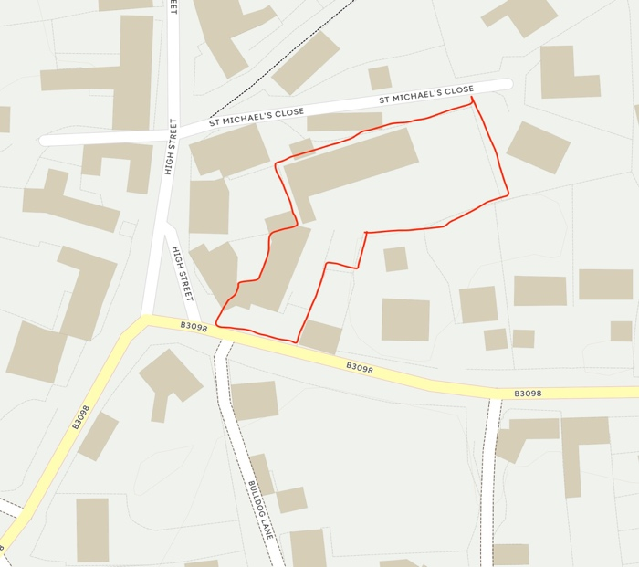

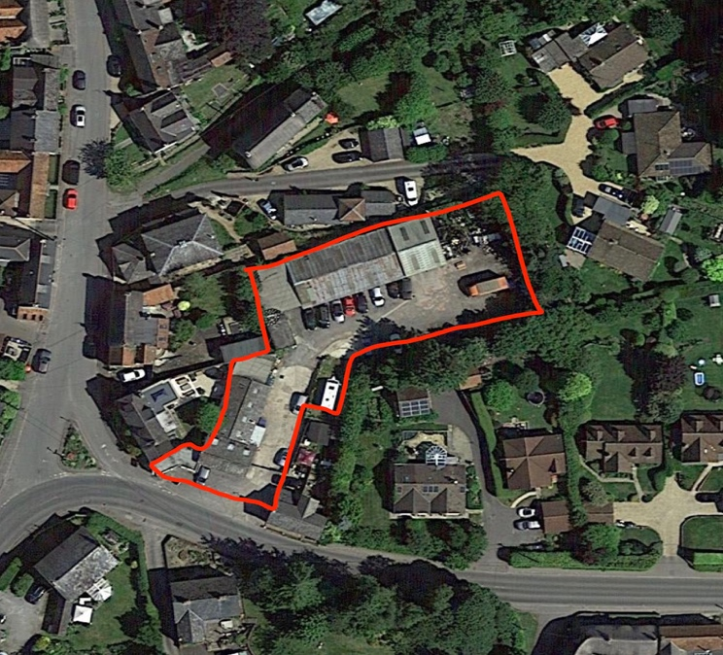
Proposal:

- Redevelopment of existing garage and workshops to provide 5 new houses, (2 x 4-bed, 2x 2-bed and 1x 3-bed)

- Site area 0.22ha/ 0.54 acres

Key Factors:

- Brownfield site, within development boundary

- Village shop/pub approximately 460 metres walking distance

- Access from B3098, with restricted visibility

- Adjoining listed building and within conservation area

- No affordable housing proposed

- Existing employment use displaced

- Tree Preservation Order on boundary

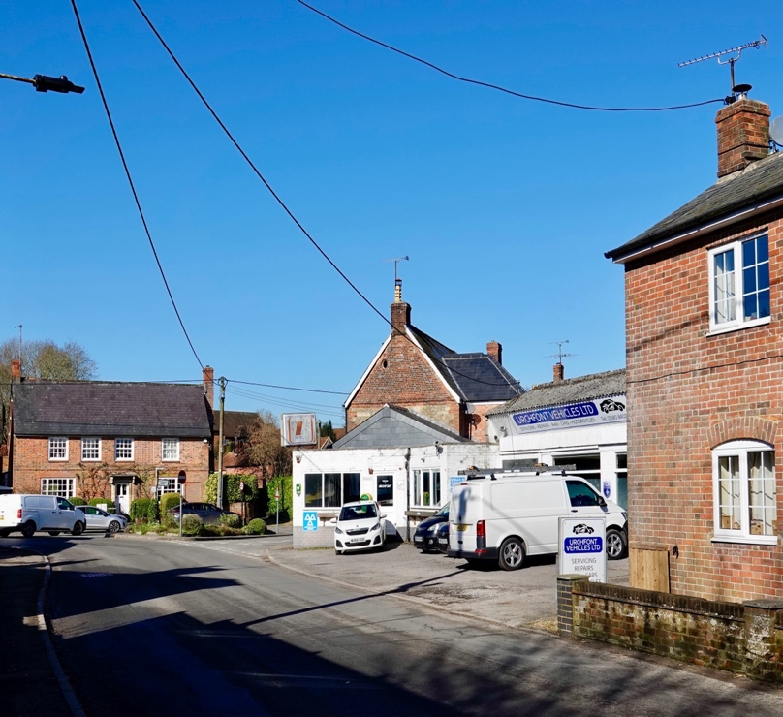

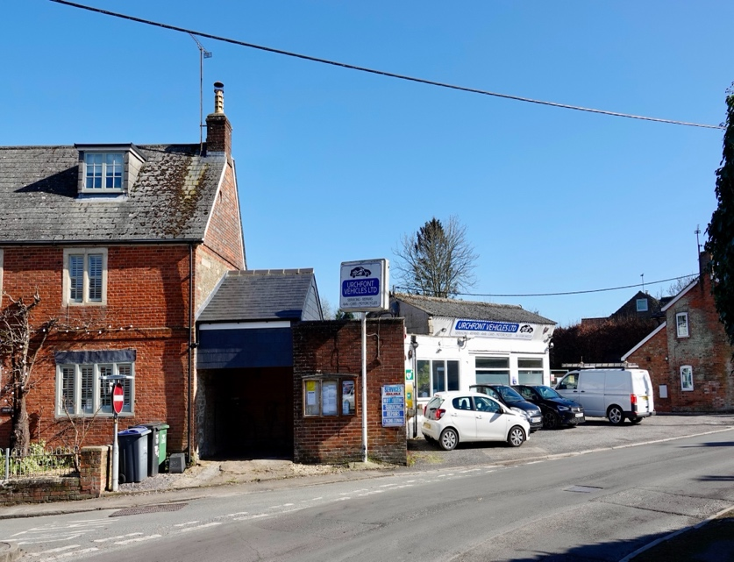
Site 2 Uphill, east of Yardlands

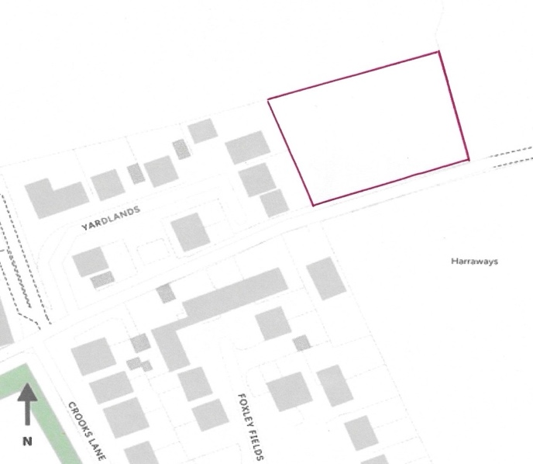

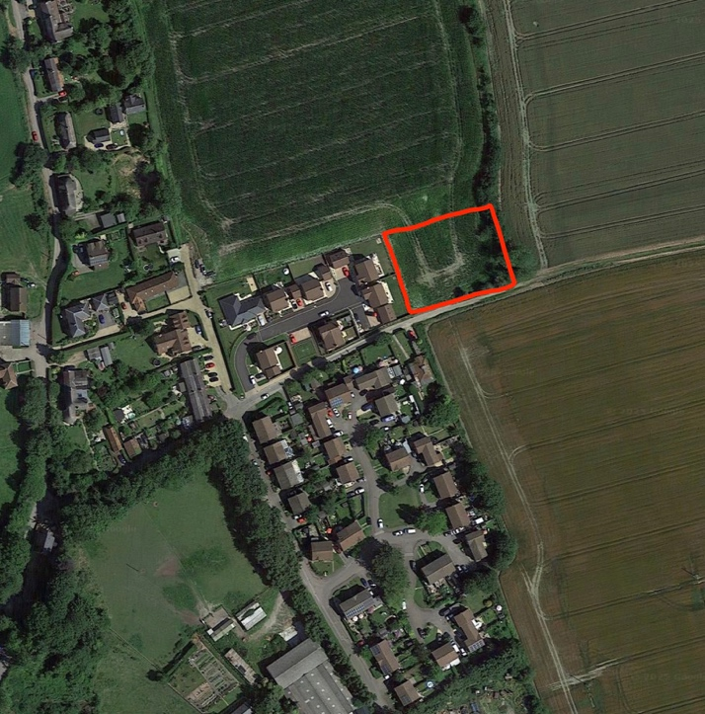
Proposal:

- 4-6 (approx.) 2- and 3-bed houses

- Site area 0.2 ha/ 0.49 acres

Key Factors:

- Greenfield site, located outside but adjacent to village development boundary.

- Projecting into existing open farmland on 3 sides, impacting views towards North Wessex Downs from footpath

- Village shop/pub approximately 920 metres walking distance

- Accessed directly from minor single-track lane with no pavements

- Public footpaths on south and east boundaries

- Modest potential for affordable housing

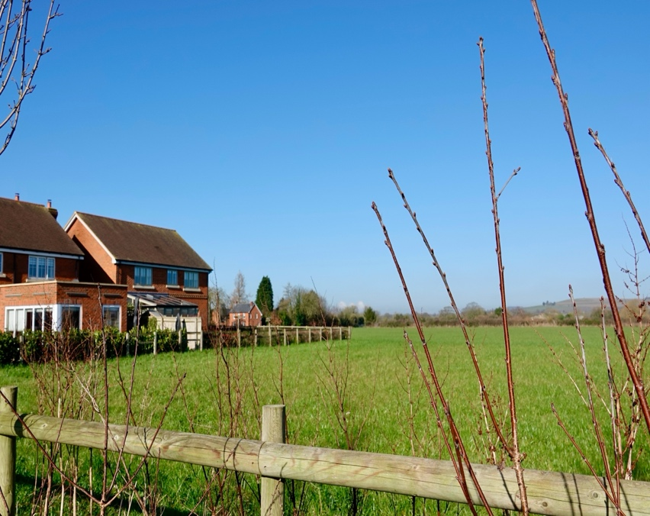

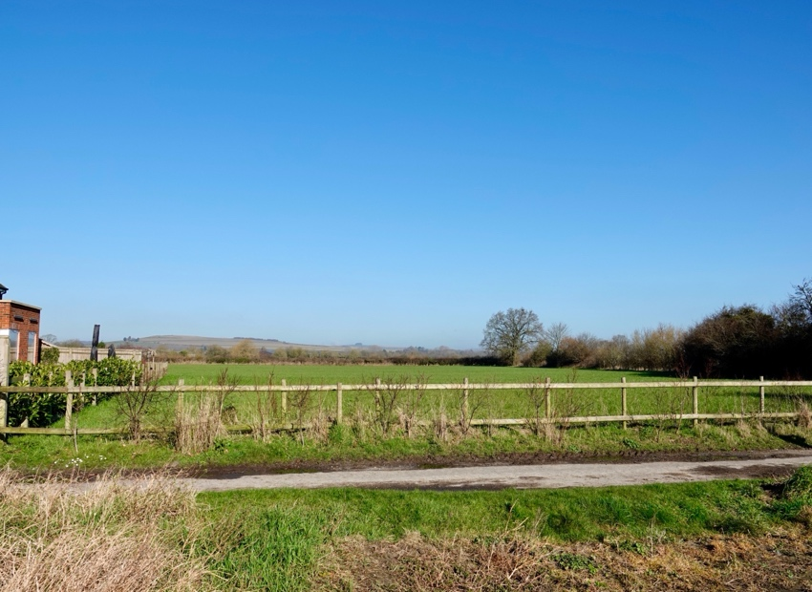
Site 3 Land south of Ballingers

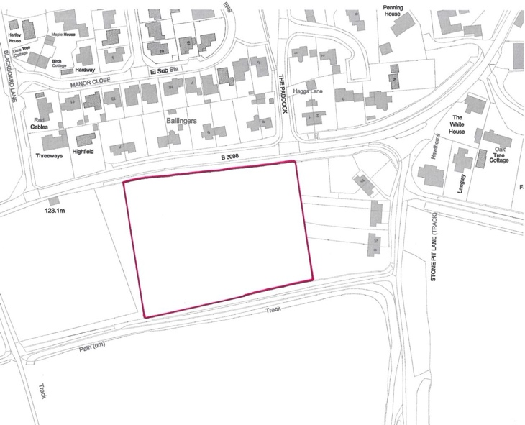

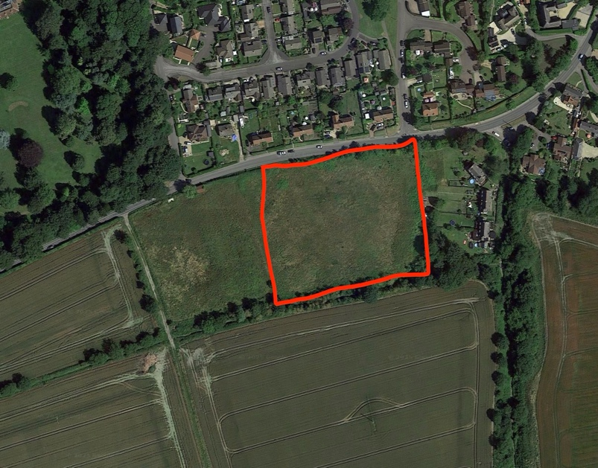
Proposal:

- New development of 21 houses with a mix of house sizes.

- Site area 1.1 ha/ 2.72 acres

Key Factors:

- Unused greenfield site, located outside but adjacent to village development boundary

- Well-screened from B3098 by existing hedgerows and trees, but with some impact on view from the Plain

- Village shop/pub approximately 375 metres walking distance

- Accessed directly from B3098

- Designated local Green Space and public footpath on southern boundary

- Appeal scheme now allowed includes provision of 30% affordable housing, self-build housing and some smaller houses

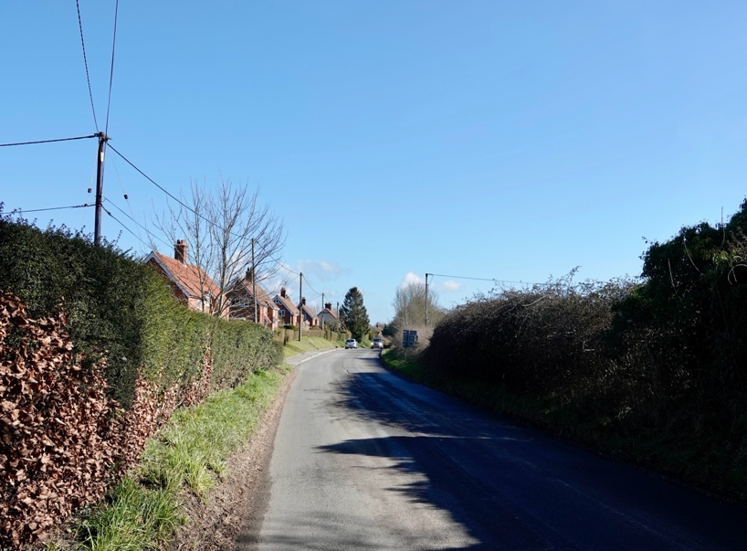

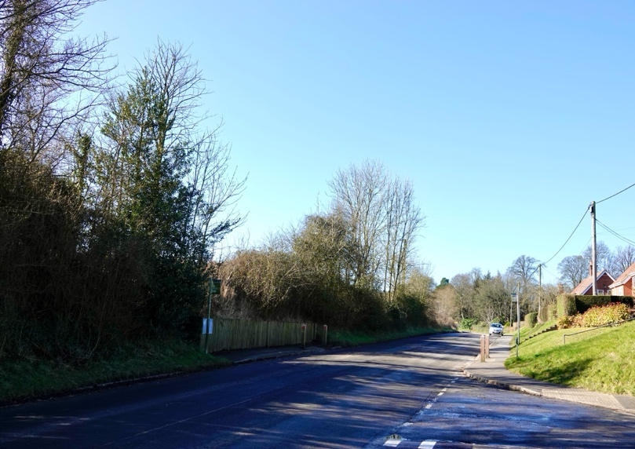
Site 4 Garden land at Alcudia, The Ham

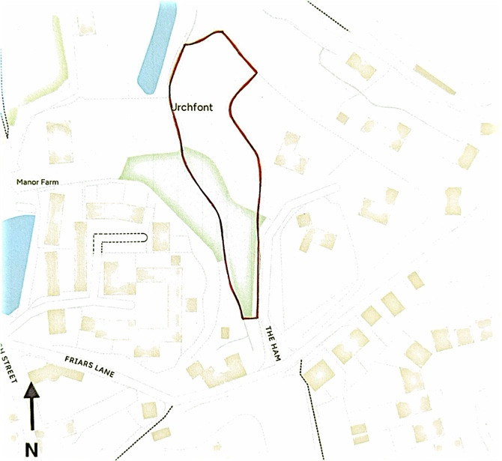

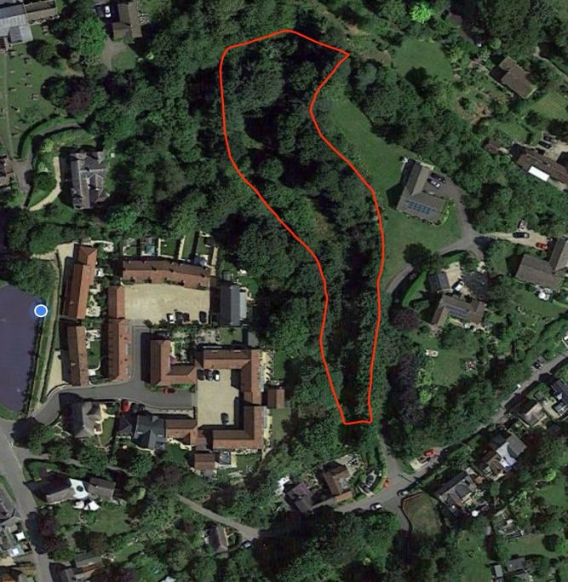
Proposal:

- Three (approx.) houses in garden of existing property

- Site area – 0.7 ha/ 1.7 acres

Key Factors:

- Brownfield site, mostly within development boundary

- Village shop/pub approximately 530 metres walking distance

- Access off narrow, single-track lane with no pavements (Friars Lane/The Bottom/Uphill)

- Tree Preservation Order on boundary

- Site proposed has steep slope dropping down to brook to the west

- Limited site with no affordable housing potential

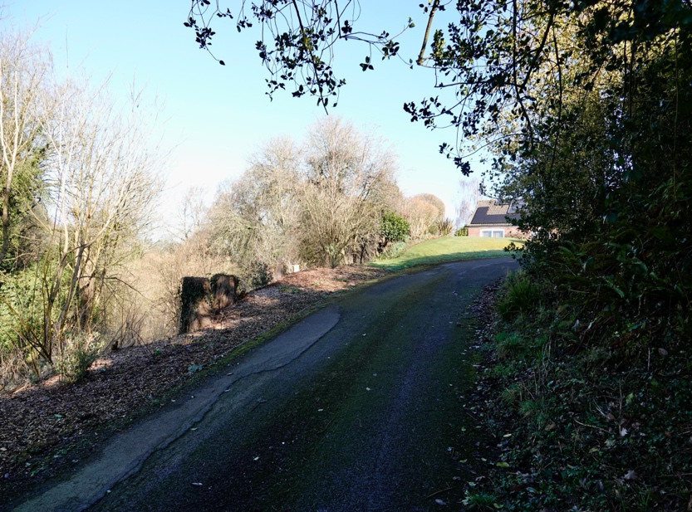

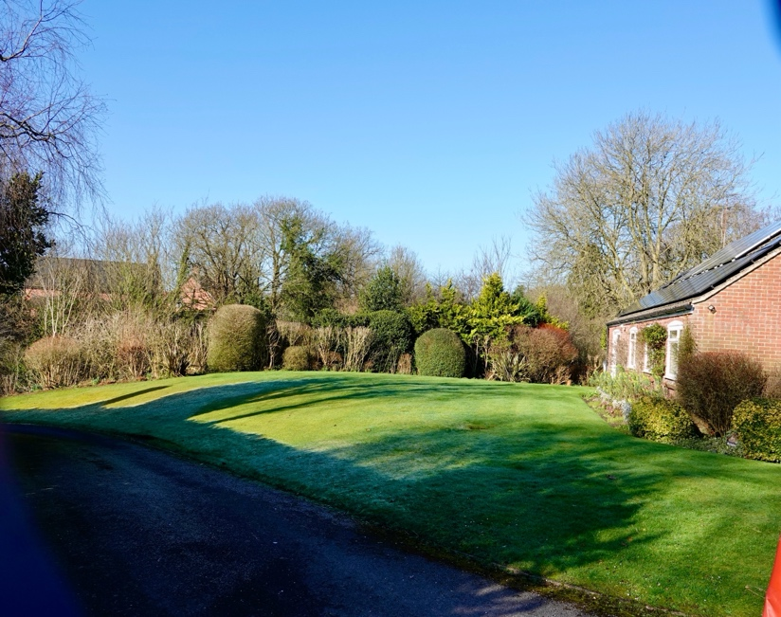

Site 6 Land Opposite “Sawmills”, Friars Lane

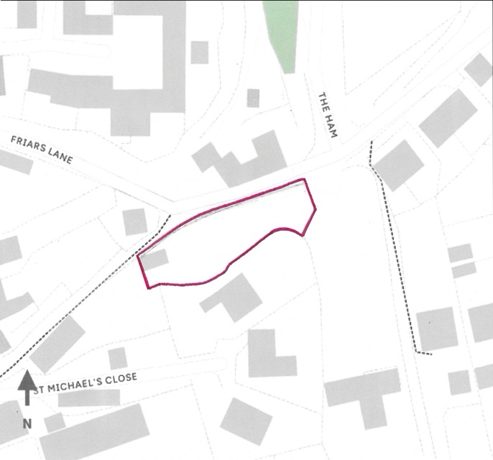

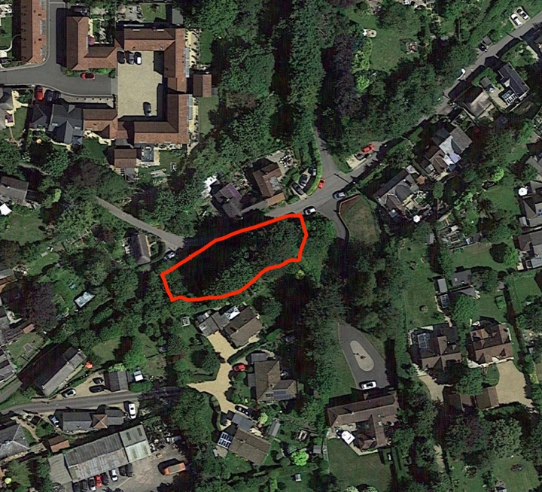
Proposal:

- Single detached house on vacant land

- Site area – 0.04 ha/ 0.1 acre

Key Factors:

- Greenfield site, within village development boundary

- Village shop/pub approximately 390 metres walking distance

- Access off narrow, single-track lane with no pavements (Friars Lane/The Bottom/Uphill)

- Opposite listed building and adjacent to conservation area

- Site at foot of steep bank and currently raised above road level

- Limited site with no affordable housing potential

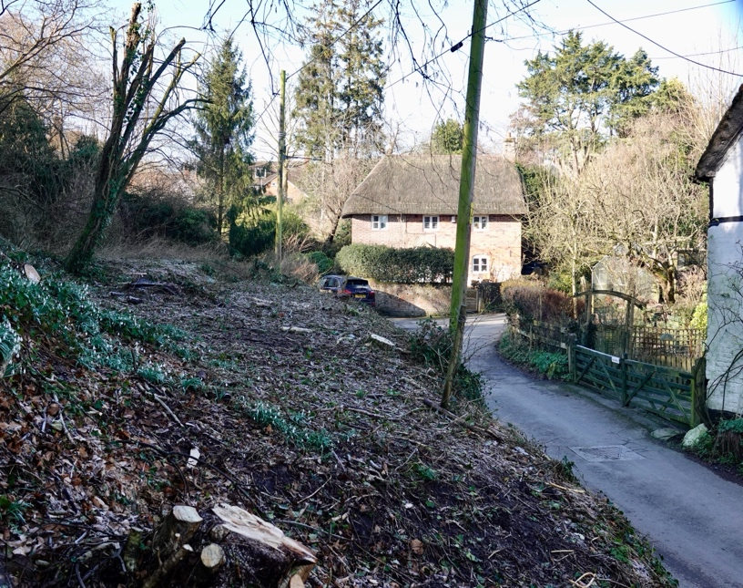

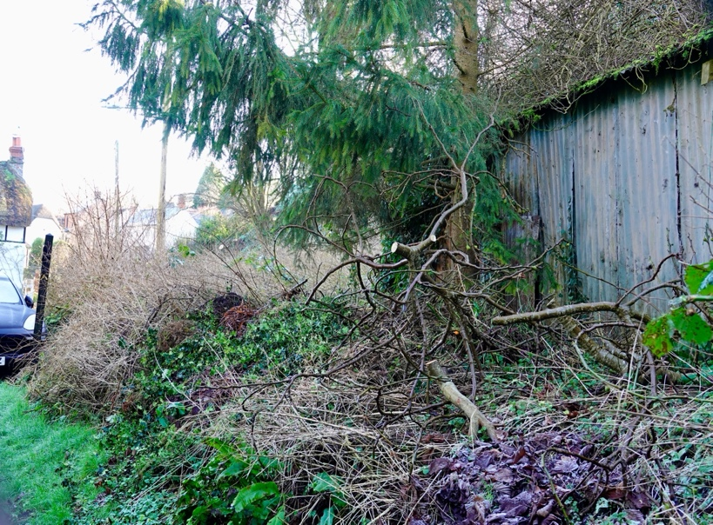

Site 7 Uphill Farm - South Paddock

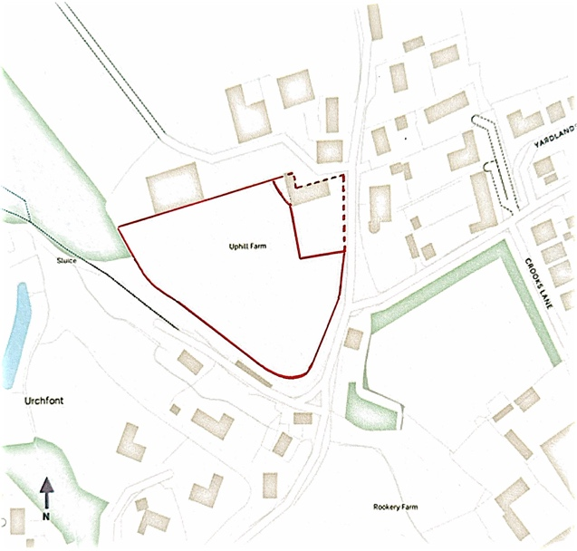

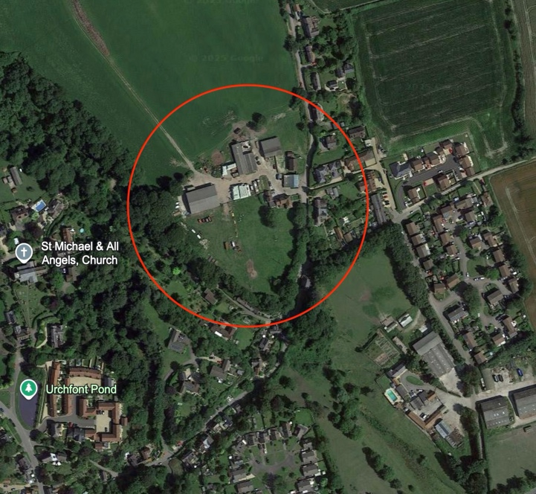
Proposal:

- 9-12 (approx.) 2-, 3-, 4- & 5-bed houses on existing paddock (potential increase to 15 (approx.) if existing house and garden included as dotted red line)

- Site area – 0.76 ha/ 1.88 acres - with potential to increase to 0.95 ha /2.35 acres, if existing house and garden included

Key Factors:
- Greenfield site, outside but adjacent to development boundaries (to south and to east opp. side of road)

- Village shop/pub approximately 775 metres walking distance

- Access off narrow, single-track lane with no pavements (Friars Lane/The Bottom/Uphill)

- Steep embankment down to south-west of site, very close to existing properties

- Local Green Space to south-west below site

- Large sized site with good potential for affordable housing in accordance with WC policy

